SIMATS ENGINEERING (SAVEETHA SCHOOL OF ENGINEERING)
Department of Computer Science and Engineering

ASSESSMENT TOOL 2 – CASE STUDY

Course Code: | CSA06 | Course Title: | Design and Analysis of Algorithms
CO Assessed: | CO3: Articulation (BL4, BL5) | Assessment: | Assessment Tool 2 – Case Study
Weightage: | 20% of CIA | Total Marks: | 100
CO3 Statement: | Design Divide and Conquer algorithms for Merge Sort, Quick Sort, Binary Search and Matrix Multiplication
Student Name: | Y. Jithendra Reddy | Reg. No.: | 192525303
Section / Batch: | AIML (2025) | Date: | 9-08-2026

Instructions to Students
- Answer the following question. Total Marks: 100.
- Carefully analyze the given case study questions.
- Explain in detail with sample code if needed.
- Clearly identify all key issues, provide an in-depth analysis, and propose innovative, feasible solutions with strong justification.

Question Type | Focus Area | Questions
Case Study | Focus on Design Divide and Conquer algorithms: Merge Sort, Quick Sort, Binary Search and Matrix Multiplication | Q1

SECTION A – CASE STUDY

Code of Conduct
I _Y. Jithendra Reddy (192525303) (Name / Reg No) certify that this submission is my original work and that I have adhered to the guidelines specified for this assessment. I understand that any violation of academic integrity rules will result in disciplinary action.
Signature of the Student: __Y. Jithendra Reddy__

RUBRICS FOR CALCULATION

 |  | Case Study
Criteria | Weightage | Level 4 –  Exemplary | Level 3 –  Proficient | Level 2 –  Developing | Level 1 –  Beginning
Understanding of Case | 25% | Thorough understanding; clearly  identifies all key issues | Good understanding with most issues identified | Basic understanding;  some issues missed | Poor understanding;  problem not  identified correctly
Application of Concepts | 25% | Effectively applies relevant concepts to  analyze the case deeply | Applies appropriate  concepts with minor gaps | Limited application of concepts | Fails to apply relevant concepts
Analysis | 20% | In-depth analysis with strong  reasoning and insights | Good analysis with logical reasoning | Basic analysis with limited depth | Weak or no analysis; lacks reasoning
Solution Design | 20% | Innovative, feasible  solutions with strong justification | Logical solutions with adequate justification | Basic solutions with weak  justification | Incorrect or no solution provided
Clarity | 10% | Clear, wellstructured, and easy to understand | Organized and understandable presentation | Limited clarity and structure | Poor clarity; difficult to understand

Marks Evaluation:
Criteria | Wt. | Level 4 –  Exemplary | Level 3 –  Proficient | Level 2 –  Developing | Level 1 –  Beginning
Understanding of Case | 25%
Application of Concepts | 25%
Analysis | 20%
Solution Design | 20%
Clarity | 10%
Total Marks (100):

Faculty In-charge | Course Coordinator | Head of Department
Name: | Name: | Name:
Signature: _______________ | Signature: _______________ | Signature: _______________
Date: ___________________ | Date: ___________________ | Date: ___________________

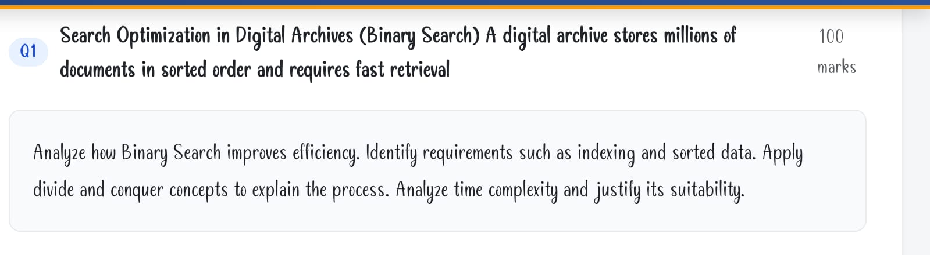

.Search Optimization in Digital Archives Using Binary Search
A digital archive stores millions of documents in sorted order. Binary Search is highly suitable because it finds a required document by repeatedly reducing the search space into half.
1. How Binary Search improves efficiency
In a Linear Search, documents are checked one by one. For millions of documents, this can require millions of comparisons.
Binary Search checks the middle document and eliminates half of the remaining documents after every comparison.
For example, for 1,000,000 documents:
Linear Search → up to 1,000,000 comparisons
Binary Search → about 20 comparisons, because �
Therefore, Binary Search provides much faster retrieval.
2. Requirements
Sorted data:
The documents must be sorted according to a searchable key such as:
Document ID
Title
Date
Author name
Indexing:
An index can store searchable keys and references to document locations. Binary Search can operate on this sorted index rather than searching the complete documents.
Random access:
The system should be able to directly access the middle element efficiently.
3. Divide and Conquer Process
Binary Search follows the Divide and Conquer technique:
Divide: Find the middle element of the search range.
Compare: Compare the required key with the middle element.
Conquer:
If equal → document is found.
If key is smaller → search the left half.
If key is larger → search the right half.
Repeat until the document is found or the range becomes empty.
Example:
Documents: [10, 20, 30, 40, 50, 60, 70]
Search key: 60
Middle = 40 → 60 > 40 → search right half
Middle = 60 → Found
Only 2 comparisons are required.
4. Algorithm
BinarySearch(A, key):
low = 0
high = n - 1

while low <= high:
mid = (low + high) // 2

if A[mid] == key:
return mid
else if key < A[mid]:
high = mid - 1
else:
low = mid + 1

return -1
5. Time and Space Complexity
Case
Time Complexity
Best Case
O(1)
Average Case
O(log n)
Worst Case
O(log n)
Space – Iterative
O(1)
Space – Recursive
O(log n)
The recurrence relation is:
Therefore,
6. Suitability for Digital Archives
Binary Search is suitable because digital archives contain very large amounts of data. Its logarithmic complexity means the number of comparisons increases very slowly even when millions of documents are added.
Conclusion: Binary Search combined with sorted data and proper indexing provides fast, scalable, and efficient document retrieval. It is therefore an excellent search technique for large digital archives.

